I wish to portray confidence. I want to identify as someone with wide experience.
I want to appear technical. I want to be approachable, organized and technical. I want to add flair to an empty boring field. An example of what you want to avoid would be a blank linux terminal. I would rather see technical information depicted in color and with some type of visual aid.
Network maps are preferable to packet tracer or other bland forms of documentation.

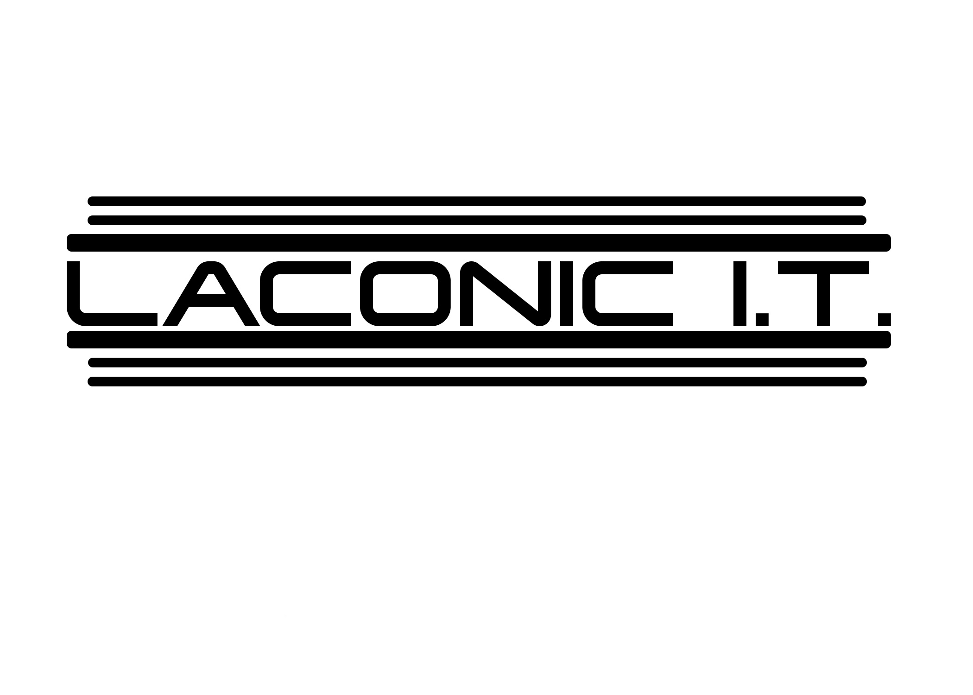

This is my company logo recently commissioned. I specified to make it look like the Terminator and this was carried out by the graphic artist. I am obviously looking for a look with something to do with cutting edge technology with a dash of tech noir, if you will.

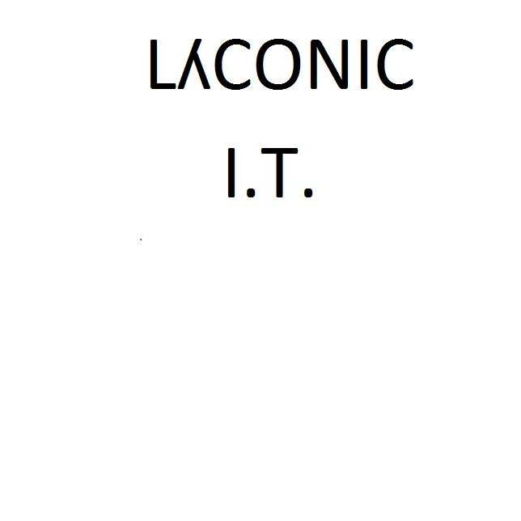
This is my older logo produced in paint. This logo includes a lambda, because of its relation to the phrase being Greek. The lambda has a pop culture association with half life, which is a win win. Also it appears in mathematics.

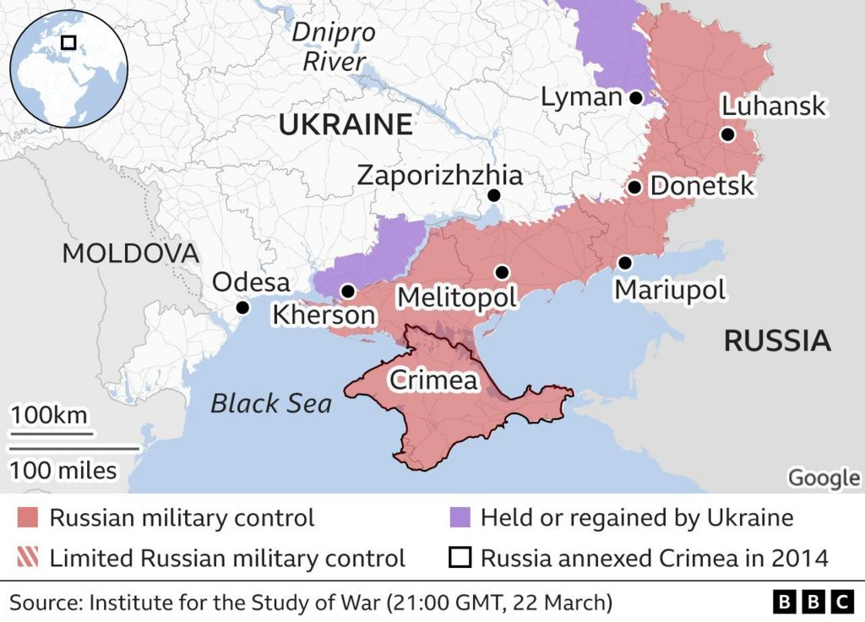
This is an example of a clear map, with detail. I would like to duplicate this clarity should I need to employ infographics for any purpose.

Serverless Compute Engine – AWS Fargate – AWS (amazon.com)

This shows a simple graphic depicting what each service does, and I like for a piece of digital rhetoric.
If I was to map out my own skills and services offered, I could use such an approach.

